Computer Science
Computer Innovation Project
Computing innovations have had considerable impact on the social, economic and cultural areas of our lives. Select a computing innovation that has significant impact, or the potential for significant impact on our society, economy, or culture, and that possesses the potential for both beneficial and harmful effects. You will use presentation software to present your information.
Choose and Research an innovation that has a significant effect on some population or group from one of the following fields: Architecture, Education, Engineering, Arts & Entertainment, Business, Communication/ Mass Media, Health and Medicine, Government, Environment, Law & Public Safety, Sciences, and Sports.
The effect could be a small effect on more than a hundred people, or a very large effect on a smaller number of people.
You will provide responses to the prompts below. Your responses should convey a deep level of understanding about your innovation and its impacts. Your responses must also include information learned from your references.
- The innovation name and a description of the intended purpose of the innovation.
- An explanation of the technical details of this innovation in terms that someone completely unfamiliar with the innovation would understand. (100 words max)
- A description of the role computing plays in implementing the functionality associated with the innovation. (100 words max)
- A description of the relationship between data and the innovation. For example, you could describe the data used or produced by the innovation or any privacy issues associated with the innovation data. (100 words max)

Impacted Population
A description of the population that is impacted by the innovation, including population characteristics such as approximate size, socioeconomic status, geographic location, health, age, gender, ethnicity, race, sexual orientation, and disability. (100 words max)

Social, Economic, or Cultural Impact
A description of the long-term and short-term impacts. (100 words max)
A description of the beneficial and harmful effects of the innovation. (100 words max)

Visual Artifact
The visual artifact must be visualization, graphic, or movie that provides additional insight to explain, clarify, or depict the beneficial or harmful effect of the innovation you selected.
Provide a textual summary to describe how the visual artifact you created illustrates the benefit or harm of the innovation.

References
Include at least two - and no more than five - references/citations to sources used to formulate your responses to this performance task.
- Each source must be a reliable newspaper/magazine article, book, news, or online source that anyone can access.
- For each reference, provide the full citation identifying the author, title, and source. For online references, include the permanent URL and the date on which you accessed the reference.
At least two of the sources must have been created within the last two years.
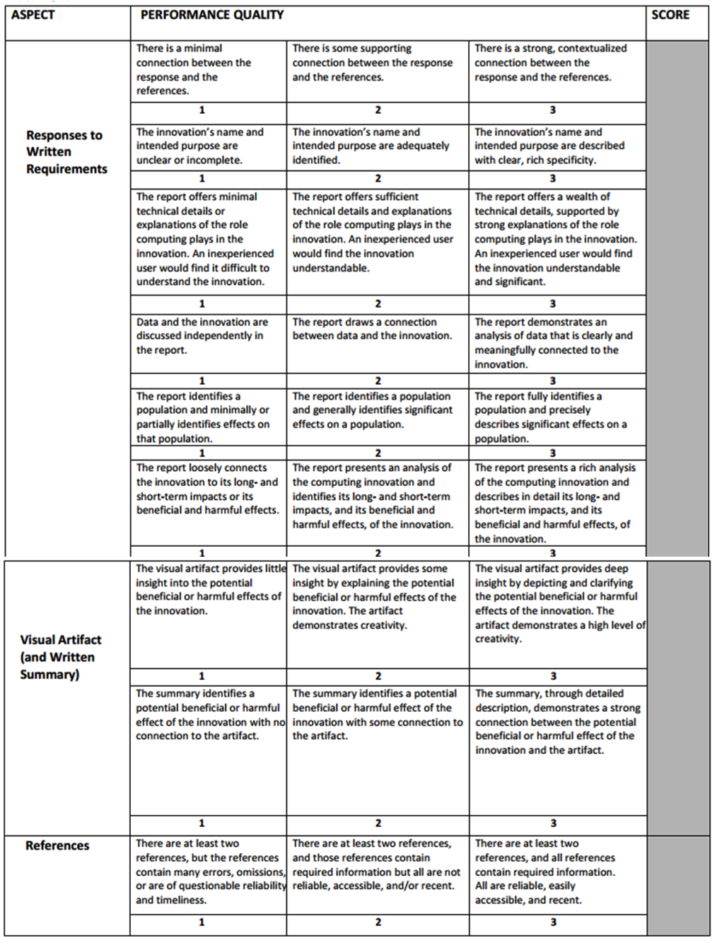
Rubric

